Capstone

Acknowledgement

I would like to extend my sincere thanks to NTUC Learning for offering the SkillsFuture Career Transition Programme – Data Analysis Association course.

My gratitude also goes to Ms. Li Ran, Course Consultant, for assisting with course registration, providing administrative support, and offering valuable learning guidance; and to Mr. Joesan Santorcas, Senior Product Manager, for organising and coordinating this programme so smoothly.

I am deeply thankful to all our trainers — Mr. Bishmer Sekaran, Ms. Bhavani Reddivari, Ms. Manisha Mane, Ms. Masumi, Ms. Pooja Chopra, Mr. Pranav Dubey, Ms. Sri Bala Malladi, and Mr. Visheshver Singh Narula — for sharing their knowledge and time with us.

A special note of appreciation to Mr. Bishmer Sekaran, Ms. Bhavani Reddivari, and Mr. Visheshver Singh Narula, who did an exceptional job explaining concepts clearly and generously sharing their real-world professional experiences — your insights made a lasting difference.

Thanks to all the classmates of batch 19. Wish everyone all the best.

This has been such a wonderful learning journey; I have gained so much from each of you. Thank you for walking this path with me.

Project: 8.1 Heart disease detection

Predictive Analytics

Objective
• This project allows to integrate and apply the knowledge, skills and concepts that you have acquired throughout the academic journey.
• It allows to demonstrate the understanding of key concepts, methodologies and best practices.
• It helps in professional development by fostering skills such as time management, teamwork and problem solving.

Problem statement
Heart disease is a leading cause of mortality worldwide. Early detection and accurate prediction of heart disease can significantly improve patient outcomes by enabling timely intervention and preventive measures. The objective of this project is to develop a machine learning model that can effectively predict the presence or absence of heart disease based on various medical and lifestyle factors.

Research objectives

- Identify possible causes of getting heart disease.

Heart disease can be caused by several risk factors, which can be divided into modifiable and non-modifiable factors.

1.1 Modifiable risk factors (Unhealthy living)

- Smoking: Damages blood vessels and increases blood pressure.

- High blood pressure: Puts extra strain on the heart and arteries.

- High cholesterol: Causes plaque to build up in arteries, restricting blood flow.

- Diabetes: Increases the risk of damage to blood vessels.

- Physical inactivity: Increases the risk of obesity and cardiovascular problems.

- Unhealthy diet: Excessive salt, sugar, and saturated fats can increase heart disease risk.

- Obesity: Makes the heart work harder and increases the risk of hypertension.

- Excessive alcohol consumption: Can contribute to high blood pressure and other heart problems.

- Chronic stress: May contribute to unhealthy habits and increased blood pressure.

1.2 Non-modifiable risk factors

- Age: Risk increases as people get older.

- Family history and genetics: A family history of heart disease can increase susceptibility.

- Sex: Risk patterns differ between men and women.

- Managing these risk factors through healthy lifestyle choices.
- About 80% of coronary heart disease is preventable by addressing lifestyle and intermediate factors
- Major actionable targets: stop smoking, eat better, move regularly, limit alcohol, manage weight/BP/cholesterol/blood sugar

- Identify segments that have high chance of getting heart disease.

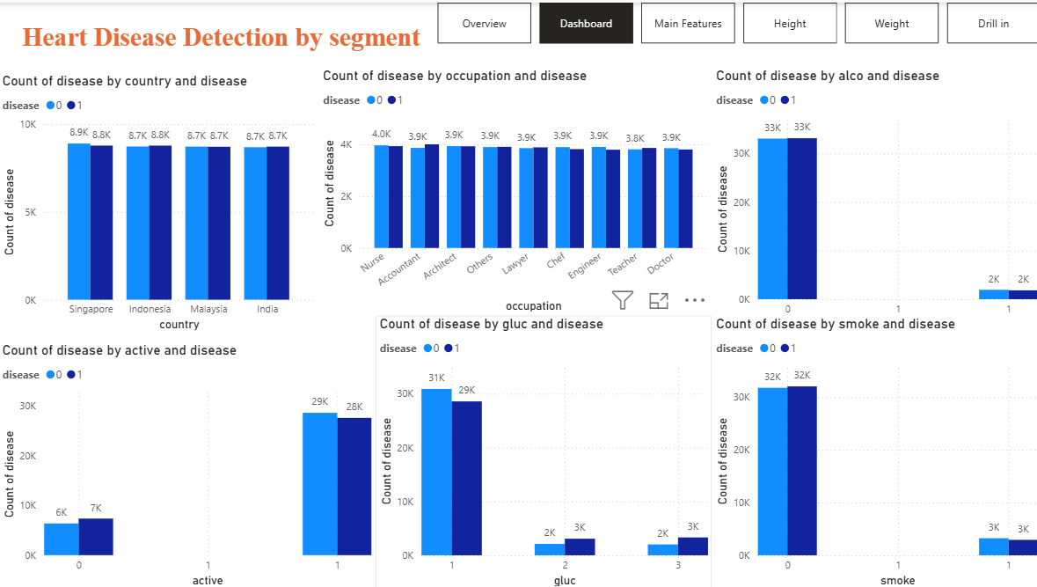
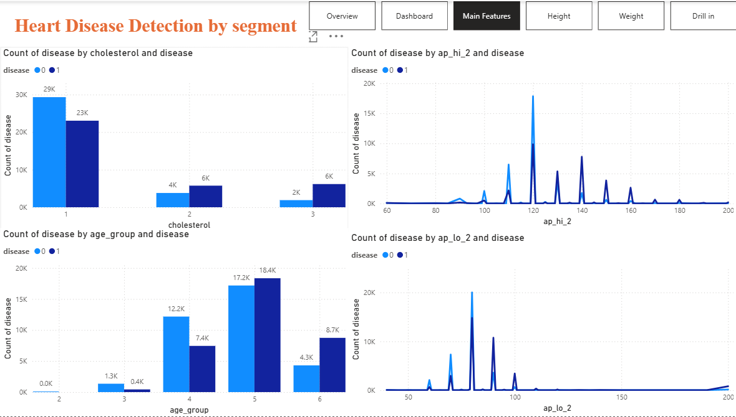

- Create models to predict heart disease.
- Linear Logistic Regression
- Linear Support Vector Machine
- K Nearest Neighbours
- Naive Bayes
- Decision Tree
- Random Forest

- Preventive measures to get heart disease.
Preventive measures can significantly reduce the risk of developing heart disease through healthy lifestyle choices and regular health monitoring.

1. Maintain a healthy diet: Eat more fruits, vegetables, whole grains, and lean proteins. Reduce salt, sugar, saturated fats, and processed foods.

2. Exercise regularly: Aim for at least 150 minutes of moderate-intensity physical activity per week, such as brisk walking, cycling, or swimming.

3. Avoid smoking: Stop smoking and avoid second-hand smoke to protect blood vessels and improve heart health.

4. Maintain a healthy weight: Manage body weight to reduce the risk of high blood pressure, diabetes, and high cholesterol.

5. Monitor health indicators: Check blood pressure, cholesterol, and blood glucose regularly, especially if you have risk factors.

6. Manage stress: Practise relaxation techniques, maintain social connections, and get sufficient sleep.

7. Limit alcohol consumption: Avoid excessive alcohol intake to help control blood pressure.

- Attend regular medical check-ups: Early detection and appropriate treatment of health conditions can help prevent complications and reduce heart disease risk.

- Detection of heart disease.
Heart disease can be detected through medical assessments, diagnostic tests, and analysis of risk factors. Early detection helps doctors identify problems and provide appropriate treatment.

1. Medical history and physical examination: Doctors assess symptoms such as chest pain, shortness of breath, fatigue, and irregular heartbeat, along with family history and lifestyle habits.

2. Blood pressure measurement: Identifies high blood pressure, a major risk factor for heart disease.

3. Blood tests: Measure cholesterol, blood glucose, and other indicators that may increase cardiovascular risk or suggest heart damage.

4. Electrocardiogram (ECG): Records the heart's electrical activity to detect irregular rhythms and possible signs of heart damage.

5. Echocardiogram: Uses ultrasound to examine the heart's structure, valves, and pumping function.

6. Stress test: Evaluates how the heart performs during physical activity or medication-induced stress.

7. Coronary angiography or CT scans: Help identify narrowed or blocked coronary arteries.

Regular health screenings and timely medical assessment are important for early detection and prevention of serious complications.

Data cleaning

# | Field | Min | Max |  | PCA
1 | date
2 | country
3 | id
4 | active | 0 | 1 |  | 0.5479
5 | age
6 | age_group |  |  |  | 0.2249
7 | alco | 0 | 1 |  | 0.1570
8 | ap_hi | 59 | 201 |  | 0.0680
9 | ap_lo | 40 | 201 |  | 0.0007
10 | cholesterol | 1 | 3 |  | 0.0006
11 | gender | 1 = Male | 2 = Female |  | 0.0002
12 | gluc | 1 | 3 |  | 0.0002
13 | height |  |  |  | 0.0002
14 | occupation
15 | smoke | 0 | 1 |  | 0.0002
16 | weight |  |  |  | 0.0001
17 | pca
18 | disease | 0 | 1

- gender 1 = Male 2 = Female

- Blood pressure restricts to the following range.
ap_hi 59 to 201
ap_lo 40 to 201

Replace with min (59, 40) or max value (201).
The other fields can still be used.

- age_group = age / 3650, 10 years bin

- added field pca = 0.5479*active + 0.2249*age_group + 0.1570*alco + …
- Label encoding
- One-hot encoding
- Z-score normalization, height, weight

Insights
- 4 Main features: age_group, ap_hi, ap_lo, cholesterol. 71% accuracy
- Age group getting heart disease
>= 30 - 24.3%
>= 40 - 38.0%
>= 50 - 51.6%
>= 60 - 67.0%
- Blood Pressure heart disease when ap_hi > 130, ap_lo > 90
- Cholesterol
1 - 44%
2 - 60.2%
3 - 76.5%
- No significance of heart disease by country, occupation, gender, active, alco, gluc, smoke

Models

Create models to predict heart disease.
- Linear Logistic Regression
- Linear Support Vector Machine
- K Nearest Neighbours
- Naive Bayes
- Decision Tree
- Random Forest

References

- Learning YouTube

- How to Clean Data in Excel in 10 Minutes
MyOnlineTrainingHub
https://www.youtube.com/watch?v=oT4emh72fuA

- Every Analyst Should Know These VSTACK Tricks
Leila Gharani
https://www.youtube.com/watch?si=pNKrm7mx80WB2gLd&v=UEDQ9CalxBI&feature=youtu.be

- Python in Excel: 1-minute Hacks You Can Use Today, Python in Excel
Leila Gharani
https://www.youtube.com/watch?v=FicDbWkofnI

- Excel vs Power BI vs SQL vs Python
Maven Analytics
https://www.youtube.com/watch?v=ODSJ1Amgcik&list=PLGAnLqlBhx1EptV8UtVLM0fRA7UDsnd59

- Visual Calculations in Power BI - DAX Made Easy!
https://www.youtube.com/watch?v=JITM2iW2uLQ&t=3007s

- Power BI Tutorial for Beginners
https://www.youtube.com/watch?v=VaOhNqNtGGE

- Python Full Course for Beginners
https://www.youtube.com/watch?v=_uQrJ0TkZlc

- Data Analysis with Python - Full Course for Beginners (Numpy, Pandas, Matplotlib, Seaborn)
https://www.youtube.com/watch?v=r-uOLxNrNk8

- Introduction to data analysis with Pandas and Python:
https://www.youtube.com/watch?v=vmEHCJofslg

- Setup

- Anaconda Navigator, Jupyter Notebook
https://www.anaconda.com/download/success

- Python

- Interactive Python tutorial
https://www.learnpython.org/en/Hello%2C_World%21

- NumPy
https://numpy.org/
https://www.w3schools.com/python/numpy/numpy_intro.asp

- Pandas
https://pandas.pydata.org/pandas-docs/stable/reference/
https://www.w3schools.com/python/python_intro.asp
https://docs.python.org/3/

- 2 libraries in python to create visualizations
- matplotlib: https://matplotlib.org/stable/api/pyplot_summary.html
- seaborn: https://seaborn.pydata.org/tutorial/introduction.html
  - plotly: https://plotly.com/

- Others

- Python for Data Analysis, ebook
Wes McKinney, August 2022: Third edition

- cs.cmu.edu/~tom/files/MachineLearningTomMitchell.pdf
Tom M. Mitchell, 1997

- Machine Learning
https://scikit-learn.org/stable

- Publicly available official Microsoft content:
https://learn.microsoft.com/en-us/credentials/certifications/data-analyst-associate/?practice-assessment-type=certification#certification-prepare-for-the-exam

- Practice SQL online
https://sqlbolt.com/

- Introduction to statistics for data science
https://www.khanacademy.org/math/statistics-probability

- Social Science Statistics
www.socscistatistics.com

- Excel’s Data Analysis ToolPak

- Introduction to Statistics, Khan Academy’s
Statistics and Probability

- https://chatgpt.com/

- https://www.dola.com/chat/

